**A PBL-I REPORT**

**ON**

**“SMART DOG FEEDER”**

A PBL-I report submitted in partial fulfillment of the requirements for the degree of

BACHELOR OF TECHNOLOGY in COMPUTER SCIENCE & ENGINEERING

Submitted By:

Patoliya Shyam [22070122141]

Peeyush Kumar [22070122145]

Pranshu Gupta [22070122156]

Ritam Mishra [22070122165]

UNDER THE GUIDANCE OF

Dr. Rupali Gangarde

Assistant Professor



**DEPARTMENT OF COMPUTER SCIENCE & ENGINEERING**

**Symbiosis Institute of Technology, Pune**

**Symbiosis International (Deemed University)**

**SMART DOG FEEDER**

A PBL-I project report submitted in partial fulfillment of the requirements for the degree of Bachelor of Technology in Computer Science & Engineering

*By*

Patoliya Shyam [22070122141]

Peeyush Kumar [22070122145]

Pranshu Gupta [22070122156]

Ritam Mishra [22070122165]

Under the guidance of

**Dr. Rupali Gangarde**

Assistant Professor

**DEPARTMENT OF COMPUTER SCIENCE & ENGINEERING**

**Symbiosis Institute of Technology, Pune**

**Symbiosis International (Deemed University)**



**CERTIFICATE**

This is to certify that the PBL-I Project work entitled “**Smart Dog Feeder**” is carried out by **Patoliya Shyam Gopal, Peeyush Kumar, Pranshu Gupta, Ritam Mishra,** in partial fulfillment for the award of the degree of **Bachelor of Technology** in **Computer Science & Engineering**, Symbiosis Institute of Technology Pune, Symbiosis International (Deemed University) Pune, India during the academic year 2023-2024.

___________________

Signature of

Dr. Rupali Gangarde

**ABSTRACT**

Due to different reasons and circumstances pets could miss the time to eat. So, an IoT based pet feeder with Google Assistant based remote control was proposed as a viable solution to this problem. The IoT Pet Feeder is a simple, efficient and cost effective machine that would provide meal to the pets on time no matter where the owner is . For this, I used some major components/module which are as follows:

- NodeMCU ESP8266 microcontroller as main controller

- Servo motor for pet food dispensing

- A 16*2 LCD module paired with the NodeMCU to display time.

No Real Time Clock (RTC) was used.Instead of using a Real-Time Clock module for timekeeping, the project uses Network Time Protocol servers to accurately synchronize the time, allowing users to sync the pet feeder without the need for an additional RTC. Therefore, the project allows the elimination of various components, reducing the resource costs and overall complexity. The use of the IoT Pet Feeder with core integration to Google Assistant enables a voice-controlled assistant that allows the user to either start feeding by simply saying “Okay Google, feed my pet” or configure a feeding schedule with different time indicators, such as “okay google, feed my pet today morning,” “today afternoon,” or “today evening.” The project is based on the use of an open data platform for the IoT, such as Adafruit IO.

Users can aggregate, visualize, and analyze live data on the cloud, which contributes to seamless communication between the IoT Pet Feeder and the user’s Google Assistant device. The project also utilizes If This Then That to create conditional statements that link selected Google Assistant commands with functions executed by the IoT Pet Feeder. Overall, the IoT Pet Feeder implementation process requires the following steps: hardware setup, software configuration, and connection with an external service. The NodeMCU ESP8266 microcontroller requires programming by establishing a connection with Adafruit IO and subscribing to selected feeds, enabling the receipt of commands from Google Assistant through IFTTT. After receiving the command, the NodeMCU activates the servo motor, which allows the dispense of pet food, and ensures that the feeder is working

To sum up, IoT Pet Feeder project profoundly indicates that how widely can IoT expand the functionality of our life that range to overview not only us but also our best friends. With the assistance of IoT device, feeding our pet remotely could become easier and more reliable if such things happen. Since this project helps the pet owners offset some annoyance they might encounter often, it potentially can be a good topic to explore. Besides, it strongly hints that what if we can integrate IoT devices with the virtual assistant like Google Assistant. In the near future, the steps taken in the above project have paved a way for more research in the domain of IoT pet care. We can also improve this design to enhance the user experience.

**Keywords**: IoT, Google Assistant, NodeMCU ESP8266, remote feeding, automated schedules, servo motor, cloud control.

## TABLE OF CONTENTS

|  |  |  |
| --- | --- | --- |
| **TITLES** | | **Page** |
|  | |  |
| **Certificate** | | iii |
| **Abstract** | | iv |
| **Table of Contents** | | v |
| **CHAPTER 1: INTRODUCTION** | |  |
| 1.1 | Introduction | 1 |
| 1.2 | Problem statement | 1 |
| 1.5 | Objectives | 2 |
| **CHAPTER 2: LITERATURE REVIEW** | |  |
| 2.1 | Background | 3 |
| 2.2 | Literature review and summary of the review | 4 |
| **CHAPTER 3: SOFTWARE REQUIREMENTS SPECIFICATION** | |  |
| 3.1 | Software Tool Platform/ Tools/Framework used | 5 |
| 3.4 | Functional Requirements | 5 |
| 3.5 | Non-Functional Requirements | 6 |
| **CHAPTER 4: METHODOLOGY** | |  |
| 4.1 | Architecture of the Project | 7 |
| 4.2 | Circuit Diagram Explanation | 8-9 |
| 4.3 | Hardware Setup | 9 |
| 4.4 | Setup Instruction for Google Assistance Control and Adafruit IO | 10 |
| **CHAPTER 5: RESULTS AND DISCUSSION** | |  |
| 5.1 | Results | 11 |
| 5.2 | Discussion | 12 |
| **CHAPTER 6: CONCLUSION AND FUTURE SCOPE** | |  |
| 6.1 | Conclusion | 13 |
| 6.2 | Future Scope | 13 |

**Chapter 1**

**Introduction**

* 1. **Introduction:**

Pet ownership is a proven source of immense happiness and companionship for millions of people globally. However, physically remaining with pets, and especially when considering their diet, might cause inconveniences for pet owners who have to work or travel far away from them. Often, such a situation leads to anxieties and worries about the pet’s health and food supply, as well as feelings of guilt for the owner. The solution developed in this report, therefore, is an Internet of Things Pet Feeder that can be remotely controlled by a pet owner through Google Assistant. Through IoT capabilities and a successful partnership with a virtual assistant platform widely used by millions of people, we seek to provide pet owners with a convenient and reliable way to ensure their pets receive timely and adequate nourishment, regardless of their physical presence.

In general, the IoT Pet Feeder project is driven by the goal to simplify and facilitate the process of feeding the pets and make it more convenient and manageable for the people having too much on their plate to do it in person. By enabling them to remotely control the feeding process and schedule its brining, the project aims to make the experience of owning a pet less stressful and problematic, allowing people to manage their other commitments with less concern over the well-being of their animals. Therefore, the IoT Pet Feeder project might be considered a significant development in the field of the pet care technologies and an interesting novelty in solving a common issue faced by many individuals owning a pet. Hence, through the combination if innovative IoT developments and the integration with an AI virtual assistant, this project clearly indicates the potential of technological advances to make the lives of pets and their owners easier and more convenient.

* 1. **Problem Statement:**

Many pet owners find it challenging to feed their pets appropriately when they are away. Conventional ways such as leaving the pets to neighbors or pet sitters can be inconvenient as they are not reliable. However, to keep pets healthy and prevent them from overeating, they need to be fed with at timely intervals. The problem is, therefore, the lack of an automatic feeding mechanism that allows pet owners to schedule and control feeding remotely. Current solutions offer little or no flexibility in terms of scheduling and require the manual operation. Furthermore, they may not provide necessary convenience for people living modern and dynamic lifestyles.

An IoT Pet Feeder that integrates with ease with Google Assistant. The project builds upon IoT developments and VA systems to create a reliable tool for pet owners to feed their pets while they are away from home. Subsequently, the pet’s well-being is taken care of, and owners do not have to face the inconvenience of their absence worrying about their pets.

* 1. **Objectives:**

The project goals are:

1. To design and develop the IoT Pet Feeder system such that it allows for remote controlled and scheduled pet’s feeding times.

2. To integrate the system with Google assistant allowing a user to command a voice via Google assistant to feed her/his pet.

3. To integrate a user interface system that allows for setting of schedules and controls via Google assistant.

4. The system will ensure the feeding processes are done via IoT technologies.

5. To integrate the system and existing virtual assistant platforms and other IoT ecosystems to enhance user experience and functionalities.

6. To test and validate the designed and developed IoT Pet Feeder system to ensure they are effective and meet the requirements of the pet.

7. Document the design, implementation, and testing procedures in order to present a detailed set of instructions for the subsequent creation and application of similar IoT pet care solutions.

8. Research and discuss potential modifications and expansions of the IoT Pet Feeder system in order to develop new functions or synchronize it with other smart home appliances to provide an even better pet care routine for an owner.

**Chapter 2**

**Literature Review**

* 1. **Background:**

This project is based on the fact that IoT technology and virtual assistant platforms have gained increasing popularity across various domains, one of which is home automation and pet care. In the last several years, the growth of the number of smart solutions that provided convenience, efficiency, and connectivity in the performance of multiple daily tasks has been observed. In terms of pet care, traditional ways of feeding and expecting pets to adapt their mealtime to people’s schedules remain less flexible and, importantly, available for people who are often out of home. As a result, the industry has been exploring IoT solutions to enable remote monitoring and interaction between pets and their owners. Moreover, the introduction of virtual assistant platforms, such as Google Assistant, has allowed controlling the work of IoT device with voice; therefore, integrated work provides enhanced user experience and accessibility.

To sum up, the project’s background lies in the integration of IoT technology and virtual assistant platforms and the increasing need for intelligent pet care solutions. Combining previous studies and advancements in the area, this project can promote the development of pet care solutions based on IoT that are easy, quick, and reassuring for the pet owners.

* 1. **: Literature review and summary of review**

This is a comprehensive research regarding the system implementation study of the smart pet monitoring and feeding system using IOT technology. The system aims to solve the problems experienced by a pet owner in monitoring and feeding homes in an efficient way and in today’s busy economic life. the system includes; smart pet door, the pet food feeder, and the GPS tracker for a pet. The research can be used to determine how automated pet feeders are becoming more important in modern-day pet caring. It further describes the structural design of the automatic dog feeder using a microcontroller from the IOT technology and the use of IOT technology and control systems in remote control monitoring as well as feeding the pets.

In this section, the technical aspects involved in the development of the smart pet monitoring and feeding system as identified. Some of the computer languages include HTML, CSS, and JavaScript, which are used in web development and interaction. The platform used in communication and backend management includes Anto.io and Firebase . From the data collected from the interviews, the study will achieve the research on the trends of the public’s perceptions of smart home devices base on the SCOT framework. The study is also anticipated to address the significance of the increased reliance of smart home devices and how society improves technology development. The result from the experiment can also be indicated as demonstrated in the system’s ability to enable food delivery at conducive times over time plan . Different feeding plans are timed differently for breakfast, lunch, and supper, with each plan having different amounts.The system is tested with three types of dog food brands to collect dietary data and compare it with the weight of each dog, demonstrating the system's ability to dispense food accurately and efficiently.

In conclusion, the study focuses on the implementation of the smart pet monitoring and feeding system, the system that is convenient and efficient for pet owners. Scheduling the feeding time for the pets and monitoring the feeding system’s operation through the web interfaces provides additional conveniences and pleasant experiences for everyone taking care of pets. IoT and adequate control systems guarantees the pet owners should not compromise their daily activities to guarantee their pet’s well-being. Its proper feeding and monitoring of their pet parent would be required when a rapid health-related issue will erupt.

**Chapter 3**

**Software Requirements and Specifications**

* 1. **Software Tool Platform/ Tools/Framework used:**

The software tools, platform, and frameworks used in the IoT Pet Feeder project include:

1. Arduino IDE: The Arduino Integrated Development Environment is utilized for writing, compiling, and uploading code to the NodeMCU ESP8266 microcontroller. The environment is primarily utilized for the coding and operation of microcontroller firmware.
2. Adafruit IO: is a cloud-based platform that enables Internet of Things capabilities by offering a variety of offerings for data aggregation, visualization, and interpretation. Adafruit IO is used in this technique to transmit Google Assistant commands to the NodeMCU ESP8266 through the usage of MQTT.

1. IFTTT: Another option is the IFTTT service, which is a web-based tool. This service enables the creation of conditions, also known as applets that are activated by triggers from various services. In this example, IFTTT was used to create conditions using voice commands from Google Assistant, which were then linked to Adafruit I/O action.
2. NTP Client Library: This library is necessary to synchronize the NodeMCU ESP8266’s time with Network Time Protocol servers. It provides accurate time measurement for programming the feeding schedule and eliminates the necessity for connection to a Real-Time Clock module.
3. Arduino Libraries: an additional set of Arduino libraries is required for working with different hardware. This includes the servo motor, LCD module, and I2C communication, each of which has pre-composed functions to operate and communicate these peripherals.
   1. **Functional Requirements:**
4. Remote Feeding Control: The system should allow users to remotely feed their pets using Google Assistant voice commands around the globe. The specific command that the voice recognition system should process includes “Okay google feed my pet” to trigger the process; hence, such a command is straight to the point. It can work, and another command is “Okay google feed my pet today morning.” The schedule should as follows: morning, noon, and evening.
5. Automatic Dispensing: The system should allow automatic dispensing through the feeding bottle when the voice recognition or schedule time is activated.
6. Servo Motor Control: The system should control a servo motor to open and close the feeding bottle mechanism, allowing the precise dispensing of pet food.
7. Time Synchronization: The system must synchronize its internal clock with NTP servers on a regular basis to ensure accurate timekeeping needed to schedule feeding times.
8. Status Display: The system must also have a screen to display time and feeding schedule for the user to check.
9. Integration with Adafruit IO: Since the system will get control signal remotely, I will use Adafruit IO to communicate with Google Assistant and microcontroller via MQTT.
10. Internet Connectivity: The system must be connected to the Internet to communicate with the Adafruit IO server for obtaining voice command from the Google Assistant.
11. Reliability and Safety: The system must be stable and safe to ensure proper functionality needed to feed pets without harming them or property.
    1. **Non-Functional Requirements:**
12. Reliable; this encompasses the ability of the system to feed pet food based on scheduled feeding times or voice commands without failure or frequent errors.
13. Accurate; the timings fed to the system should align with the actual feeding times to ensure that the pet receives food at the scheduled times.
14. Responsive; the ability of the system to action voice commands issued via Google Assistant within acceptable time limits eliminates the delay between command issuance and feeding action.
15. Scalable; the system should be flexible to accommodate advanced features and additional enhancements, for example, it should have the potential to work for multiple pets or feeding times.
16. Secure; the system must have controls that limit unauthorized access to the feeding mechanism guards.
17. Usability: The user interface for both the voice commands and any connected mobile app or web interface should be easy to use and intuitive without requiring special skills from pet owners.
18. Availability: The system should be always available when users want their pets to be fed and not have long downtimes or service interruptions.
19. Compatibility: The system should be able to work with a wide range of dietary options and various container sizes to provide the best service for different pets and food alternatives.
20. Resource Efficiency: The system should use minimal electricity and network resources to save either energy or reduce operating costs.
21. Robustness: The system should be able to recover from unexpected scenarios like power outages or network interruptions.

**Chapter 4**

**Methodology**

The methodology for building the IoT Pet Feeder includes various steps such as a hardware setup through NodeMCU ESP8266, servo motor, and LCD module, circuit diagram explanation, and setup guidelines for Google Assistant control and Adafruit IO.

Here's a detailed explanation of each step:

* 1. **Architecture of the Project**

Explanation of Components and Connections, Fig. 4.1.1:

1. User Interaction (Voice Command): Users interact with the system by issuing voice commands through Google Assistant.

2. Google Assistant: Receives voice commands from the user and processes them.

3. IFTTT Service: Connects Google Assistant with Adafruit IO. Triggers actions based on specific phrases spoken to Google Assistant.

4. Adafruit IO: Cloud-based platform for IoT projects. Receives triggers from IFTTT and sends commands to the NodeMCU via MQTT.

5. NodeMCU (ESP8266): Main controller of the pet feeder. Receives commands from Adafruit IO via MQTT and executes corresponding actions. Controls the Servo Motor to dispense pet food. Retrieves time from NTP servers for scheduling feeding times. Communicates with the LCD Module to display time information.

6. Servo Motor: Mechanism responsible for opening and closing the pet feeder container to dispense food.

7. LCD Module: Displays the current time and other relevant information to the user.

8. NTP Servers: Network Time Protocol (NTP) servers provide accurate time synchronization to the NodeMCU for scheduling feeding times.

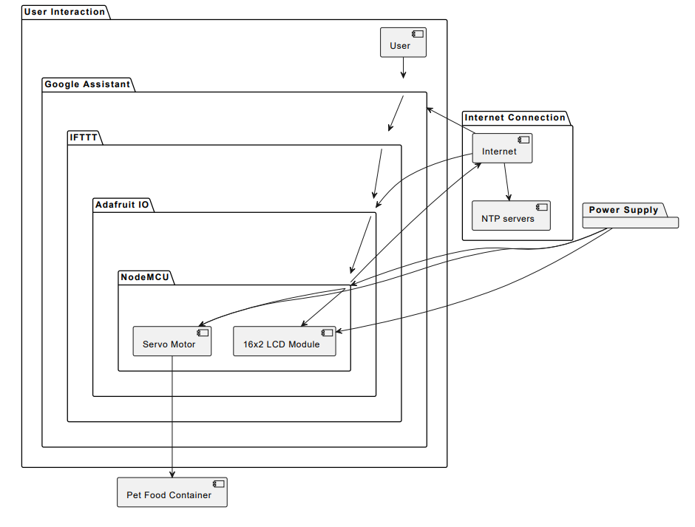

Figure 4.1.1: Architecture of Smart Dog Feeder

This architecture diagram provides a comprehensive overview of the project's components and their interactions, from user input to physical actions performed by the pet feeder. Each component's role in the system is clearly defined, along with the communication pathways between them.

* 1. **Circuit Diagram Explanation:**

The components in the circuit Fig. 4.3.1, such as the NodeMCU ESP8266, servo motor, and LCD module, are connected according to the circuit diagram.

The Vin and GND pins of the servo motor and LCD module are connected to the Vcc and GND pins of the NodeMCU ESP8266, respectively, to supply power.

The SCL and SDA pins of the LCD module are linked to the D1 and D2 pins of the NodeMCU ESP8266 for communication if the I2C interface is applied.

The servo motor controller is connected to a digital pin of the NodeMCU ESP8266.

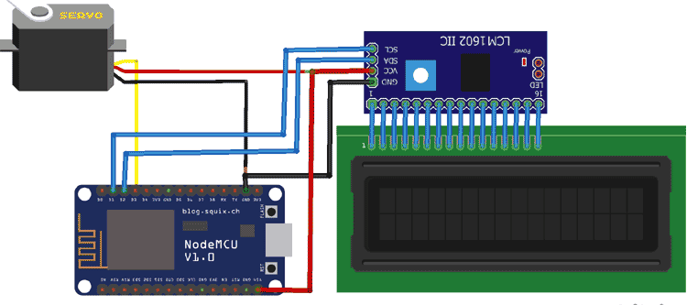

Figure 4.2.1: Smart Dog Feeder Circuit Diagram

* 1. **Hardware Setup:**
* **NodeMCU ESP8266:** The NodeMCU ESP8266, fog.4.3.1, acts as the central microcontroller for the IoT Pet Feeder. It provides sufficient processing power and enables Wi-Fi communication to allow the user to control the feeder and schedule feeding from remote locations.

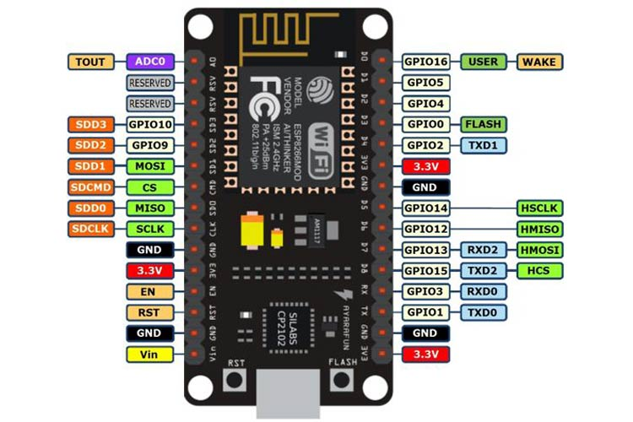

Fig.4.3.1 NodeMCU ESP8266

* **Servo Motor:** The servo motor, fig,4.3.2, regulates the feeding bottle or trap door, enabling the food to be dispensed or the passage to be opened.

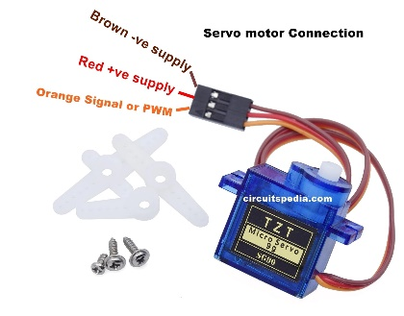

Fig.4.3.2 Servo motor

* + **LCD Module:** A 16x2 LCD module, Fig.4.3.3, is used to display the current time and, optionally, the scheduled feeding times. This provides a visual interface for users to monitor the status of the pet feeder.

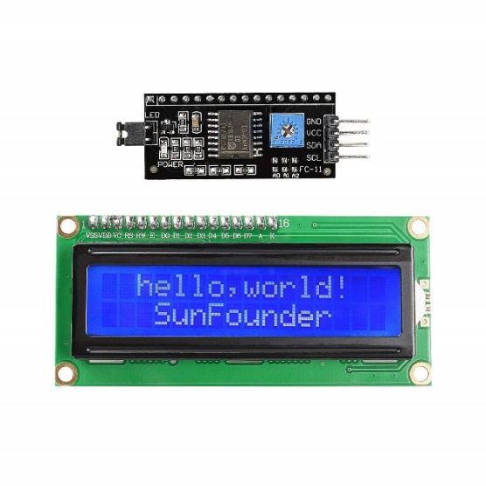

Fig.4.3.3 16 x 2 LCD display

* 1. **Setup Instructions for Google Assistant Control and Adafruit IO:**

**Adafruit IO Setup:** Adafruit IO is an open data platform used to facilitate the telecontrol and telemetry of the IoT Pet Feeder. To use Adafruit IO, users must sign up for an account and then obtain their AIO key, which they will need to make a post request and connect to Adafruit IO.

**Google Assistant Integration:** The IoT pet feeder communicates with Google Assistant via IFTTT. Users create custom applets in IFTTT that use Google Assistant voice commands to turn them into triggers and put a specific action (e.g., feed the pet) on the Adafruit IO task list. IFTTT’s Google Assistant uses the Who voice command to send commands to Adafruit IO, which then performs the tasks on the NodeMCU ESP8266, refer 4.4.1.

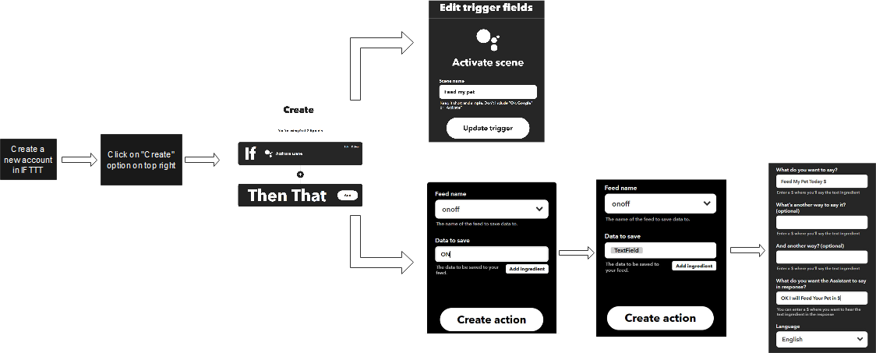

Fig. 4.4.1 IFTTT setup

**Chapter 5**

**Result and Discussion**

* 1. **Results:**

The IoT Pet Feeder project shown in Fig. 5.1.1 was successful, as it accomplished its objectives; a simple, efficient, and low-cost system that feeds pets from long distances. Moreover, users can feed pets with their voice utilizing google assistant from any place in the world. A user may also voice-command google assistant to feed the pet at particular times, making it more flexible and convenient. The hardware setup consisting of NodeMCU ESP8266, servo motor, and LCD module was an efficient method to control the feeding process and show readable information like timing and feeding times.

Moreover, the circuit diagram was explicit in connecting the wires with the right pins to ensure that the system works as required. The cloud-based platform of Adafruit IO and google assistant using IFTTT made the IoT Pet Feeder work smoothly without each of them a feed would not work. Users could easily set up applets in IFTTT to trigger feeding actions based on specific voice commands issued to Google Assistant.

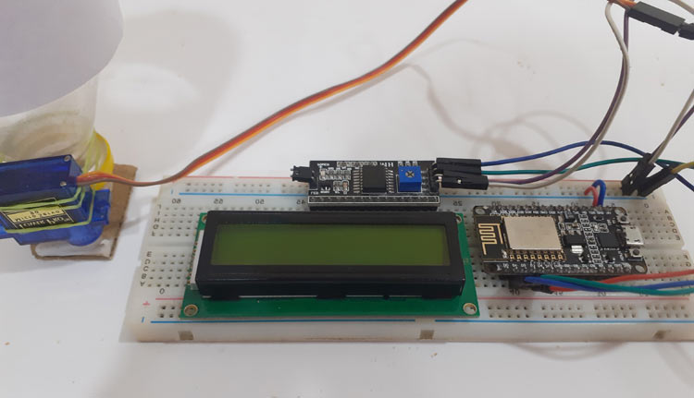

Figure 5.1.1: Smart Dog Feeder

* 1. **Discussion:**

The IoT Pet Feeder is an excellent example of how IoT technology can be used to fulfill everyday requirements such as pet feed in an easy, advanced way. The IoT Pet Feeder employs present platforms to minimize development effort and infrastructure needs such as Adafruit IO and Google Assistant and thus functions on current solutions, making it accessible to a bigger user group with expertise in these areas. The capability to access the Pet Feeder remotely is a beautiful benefit, as it expands the odds that the pet owners will not be capable to feed the animals as they have to leave town for some reason or have little time of their own.

The use of servo motors for dispensing food ensures precise control over the amount of food dispensed, reducing the risk of overfeeding or underfeeding. Additionally, the inclusion of an LCD module provides users with real-time feedback on the status of the feeder, enhancing usability and user experience.

To summarize, the IoT Pet Feeder project is a use case of the IoT in pet keeping business, improving pet owners’ convenience, flexibility as well as adding some peace of mind. In the future, the IoT-based solution, after multiple iterations and improvement, could be applied to other spheres of pet-keeping business, thus promoting the development of smart pets-keeping technology.

**Chapter 6**

**Conclusion and Future Scope**

* 1. **Conclusion:**

In conclusion, the IoT Pet Feeder project has adequately addressed and proven the possibility of using the IoT system to automate pet feeding. Using components such as NodeMCU ESP8266, servo motor, and the LCD module, as well as cloud-based platforms such as Adafruit IO and Google Assistant, the user is assured of a system that can be used to feed the pet anytime, anywhere. The IoT project employed Google Assistant voice commands and scheduled feeding times to ensure the user can control and access and feed their pet. Furthermore, the servo motor utilized makes it possible to dispense food within a precise amount, hence easy to regulate food consumed and prevent over or underfeeding.

Overall, the IoT Pet Feeder addresses a common concern among pet owners and demonstrates the potential of IoT technology to streamline pet care tasks, improve convenience, and enhance the well-being of pets.

* 1. **Future Scopes:**

There are several avenues for further improvement and expansion of the IoT Pet Feeder project:

1. Enhanced feeding control: adding custom features to the product, such as portion control, and a feature to adjust the feeding schedule to make the product suitable for different feeding requirements.
2. Smart monitoring: adding a sensor to monitor the quantity of food in the feeder, and sending the user-friendly alerts when the remaining quantity is under a certain level.
3. Health tracking: implanting the monitoring technology in the feeder to keep track of feeding habits, thus detecting the pet’s medical condition early.
4. Application: developing an application that complements the product by offering additional features and permitting voice commands on the feeder from any location.
5. Multi-pet: installing the system in multiple devices in one system, to allow multiple feeding monitoring.

By incorporating these enhancements, the IoT Pet Feeder project can evolve into a comprehensive pet care solution that offers advanced functionality, improved user experience, and greater peace of mind for pet owners.